|  |
| --- |
| Capgemini |
| Cartons less than loaded on closed shipment |
|  |
|  |
| |  |  |  | | --- | --- | --- | | **Document Update** | **Updated By** | **Date** | | Created By | Netravati D Sutar | 05/20/2016 | | Reviewed By | Sabita Prasad | 06/06/2016 | | Reviewed By | Sabita Prasad | 07/27/2016 | |
|  |

|  |
| --- |
|  |

**Issue Description:** orders will be less than loaded status but pinned to closed shipments, this can cause routing/combining shipment issues.

***Cartons less than loaded on closed shipment.***

**Severity:** High

**Description:** An email will be triggered from SCI saying, ‘SCI has detected one or more orders that are in "Less than Loaded" status, but pinned to closed shipments. This can cause routing / combining shipments issues. Please use Manual Load Planning to correct asap’. Sample copy of the email is attached below.



**Mitigation Approach:**

**Scenario 1:**

**Step 1:** Undo the routing wave by using below steps and perform manual load

planning.

Go to UI->Run Waves, select Routing wave-Undo Routing checkbox and click on Run Wave at bottom as shown below:

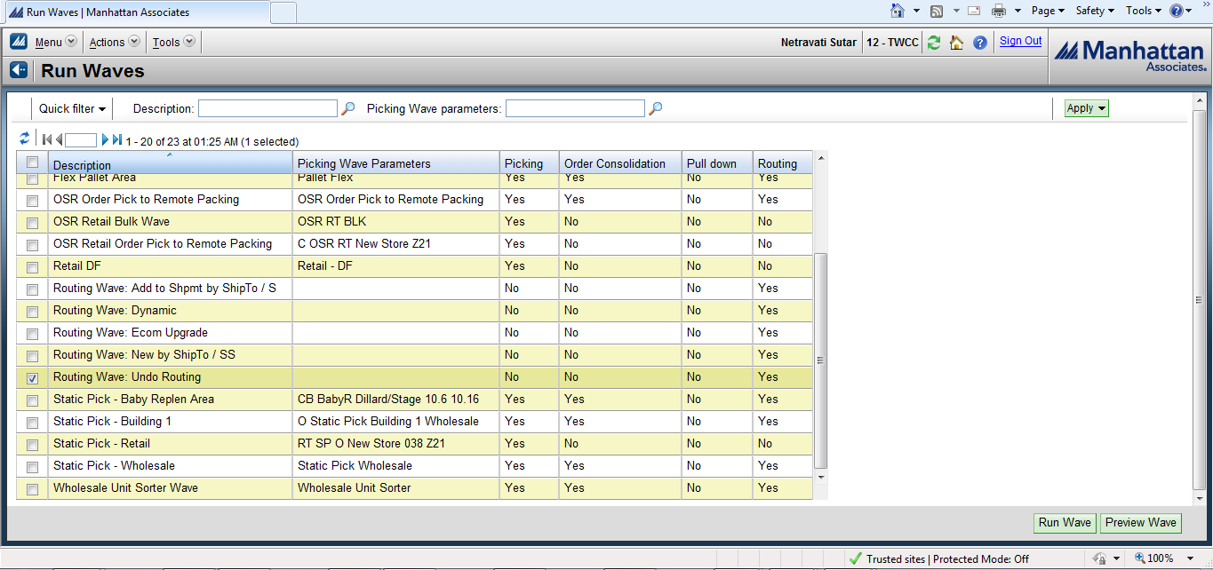

**Step 2:** You will be navigated to below screen after run wave: Choose the Rusty

PO option under Rules option and at right side under description tab,

select column name as order number, operator as equals, comparison

value as order number (which is present in mail), And/Or value as none

and click on submit button at bottom.

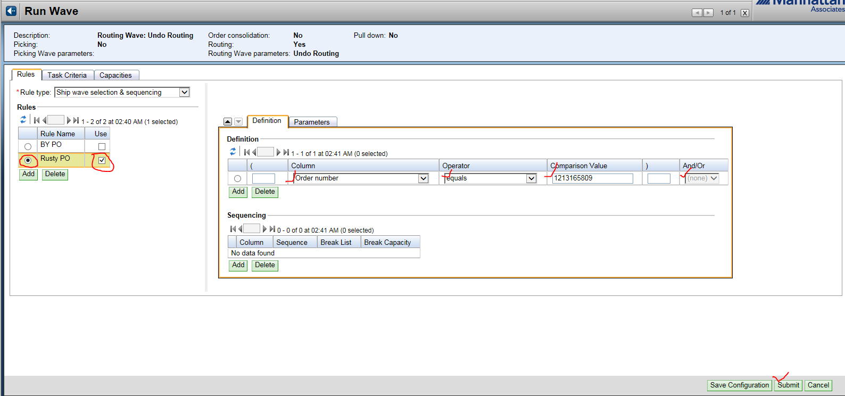

**Step 3:** Once the wave is complete, go toManual Load Planning, and enter the

order number and click on apply.

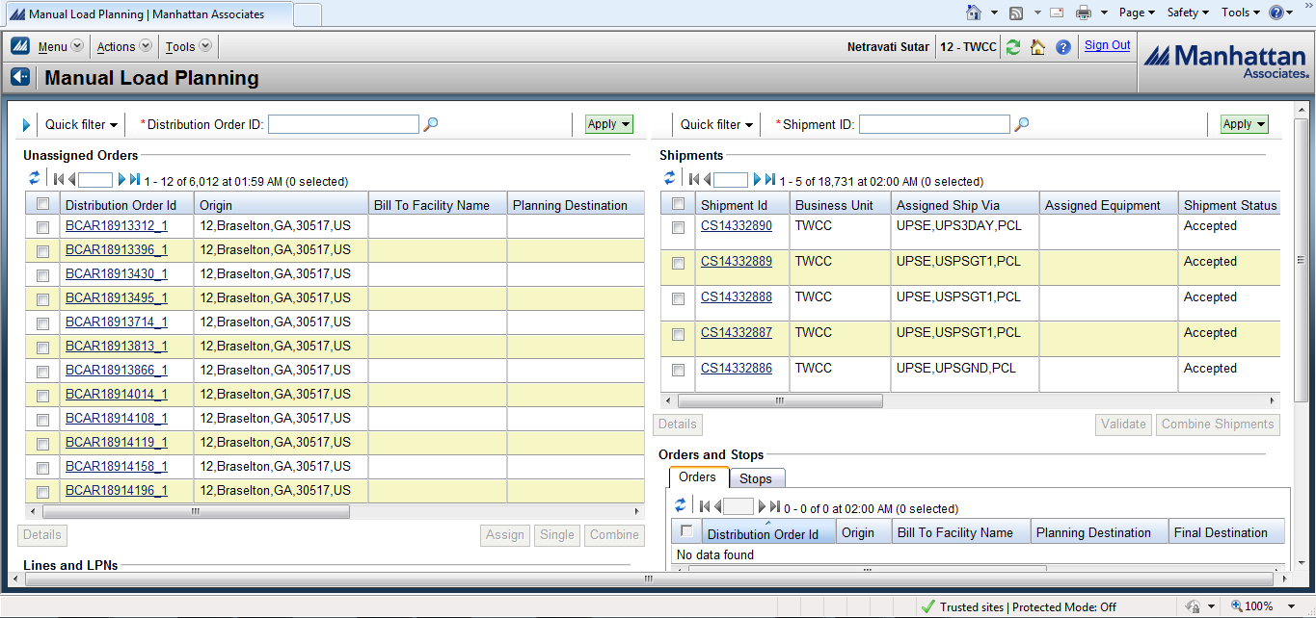

**Step 4:** Select the order and click on single button.

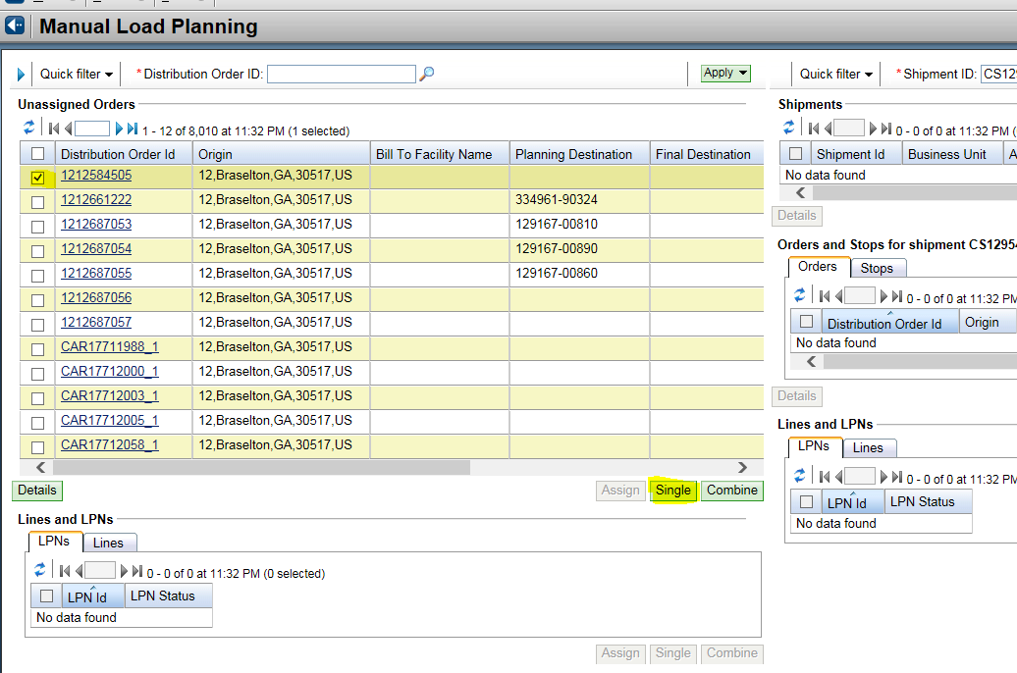

**Step 5:** Select the new shipment and click on accept workplace at bottom.

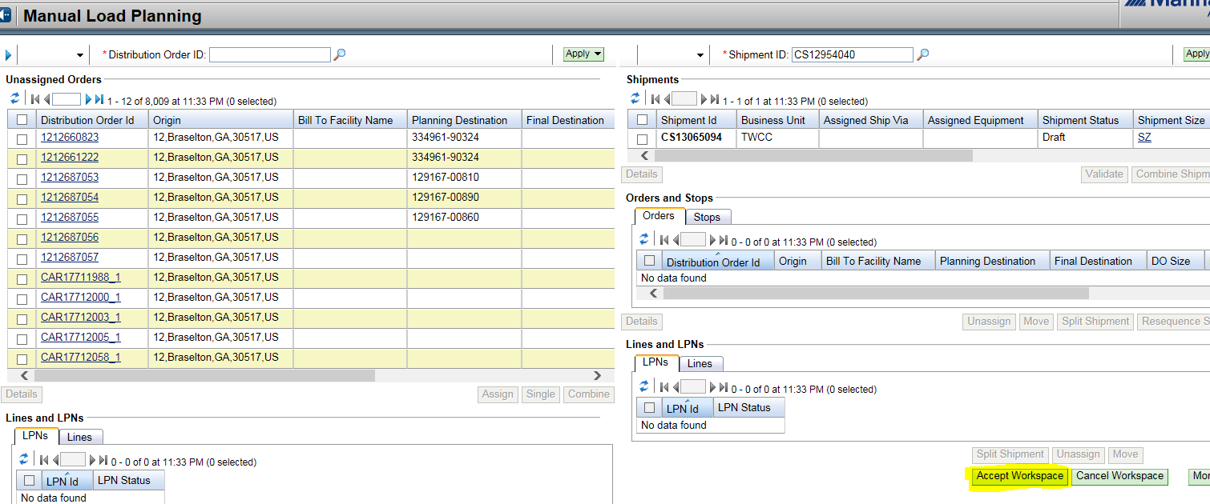

**Scenario 2:**

* After assigning new shipment to the old shipment (by following steps in Scenario 1), still the it did not updated with the new shipment. This is due to “when the user closed shipment, WM created an order split record for the order on the new shipment. Because the order split record is in 10(planned status)” .See the below attached mail for reference.



**Example:**

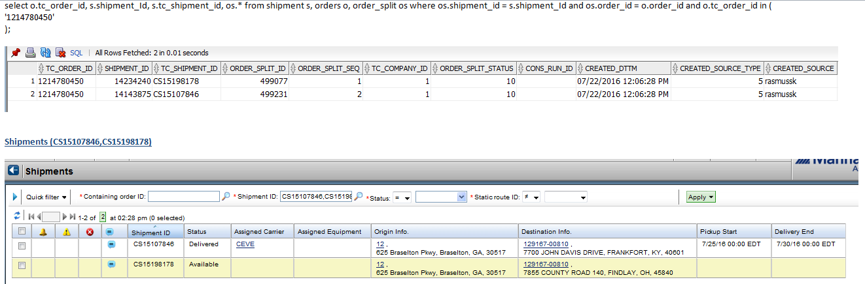

**Resolution:**

**Update the LPN record with the new Shipment_ID and TC_Shipment_ID.**

**Attached the SQL and Log file for the same.**





**Scenario 3:**

Here if the given shipment is already in cancelled status, it will not work to assign & un-assign new shipment by manual load planning.

Attached below mail is for reference:-



Step 1: Follow step 1 same as earlier Run wave->Routing wave undo routing -> Check Rusty PO -> selected order number ->Operator as equals ->Comparison value as order number.

Step 2: Manifest the carton with same ship via which you get from Carton.

Step 3: De-manifest the carton back.

Step 4: Check in DB new shipment should get updated.

This process will create new shipment for oLPN.